Title
Smart Public Washroom Hygiene Monitor

Abstract
Smart Public Washroom Hygiene Monitor is an IoT-based system designed to monitor hygiene conditions in public washrooms at places such as railway stations, malls, and universities. The system uses multiple sensors to detect factors that affect washroom cleanliness such as bad odor, floor wetness, soap availability, and user traffic.
An ammonia gas sensor detects bad odor levels, an IR sensor counts the number of people entering the washroom, a moisture sensor detects floor wetness, and a liquid level sensor monitors soap levels. All sensor data is transmitted through a Raspberry Pi microcomputer to a cloud server using the MQTT protocol. The cloud system processes and stores the data and sends real-time alerts through a dashboard when cleaning or maintenance is required.
This system enables efficient monitoring of washroom hygiene and helps ensure that sanitation issues are addressed immediately.

Problem Statement
Public washrooms in places such as railway stations, malls, and universities often suffer from poor hygiene due to lack of real-time monitoring and delayed maintenance. Washrooms may develop bad odor, wet floors, or empty soap dispensers without immediate attention.
Maintenance staff usually rely on periodic manual checks, which can lead to unhygienic conditions between inspections. Therefore, there is a need for a smart system that can continuously monitor hygiene conditions and notify maintenance staff whenever cleaning or maintenance is required.

Objectives
• Monitor hygiene conditions in public washrooms using IoT sensors.
• Detect bad odor using an ammonia gas sensor.
• Count the number of people entering the washroom using an IR sensor.
• Detect wet floors using a moisture sensor to ensure safety and cleanliness.
• Monitor soap availability using a liquid level sensor.
• Send alerts through the monitoring dashboard when maintenance is required.
• Store and analyze washroom data in the cloud for monitoring and analysis.

Architecture Diagram
System Workflow:
Sensors → Raspberry Pi → MQTT Cloud Broker → Cloud Processing → Data Storage → Monitoring Dashboard
The Raspberry Pi collects data from all sensors and transmits it to the cloud using the MQTT protocol. The cloud processes the data, stores it, and displays the information on a dashboard for monitoring by facility managers or sanitation staff.
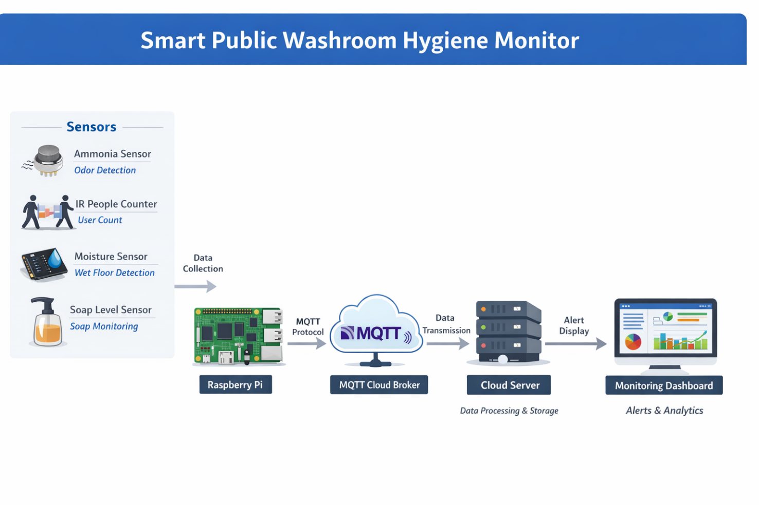

Technologies Used
Hardware Components
• Raspberry Pi for sensor integration and communication
• Ammonia Gas Sensor for odor detection
• Infrared Sensor for counting washroom users
• Liquid Level Sensor for monitoring soap dispenser levels
• Moisture Sensor for detecting wet floors
• Power supply and interfacing components

Software Components
• MQTT Protocol for IoT communication
• Cloud MQTT Broker
• Google Sheets or cloud database for data logging
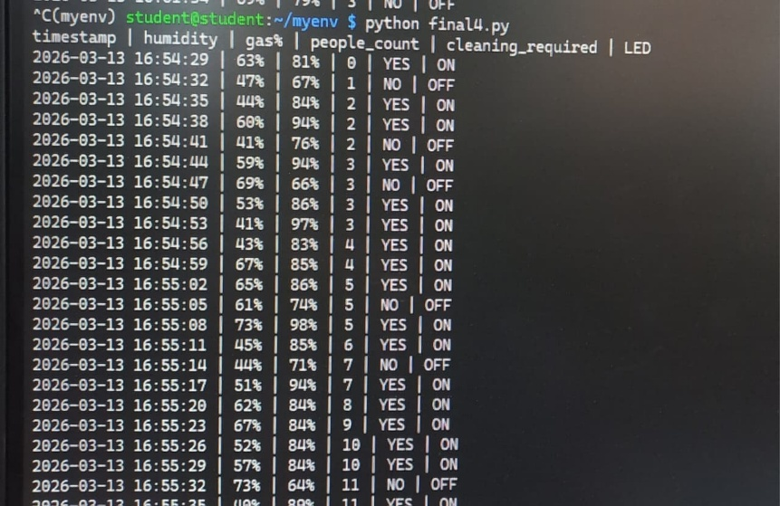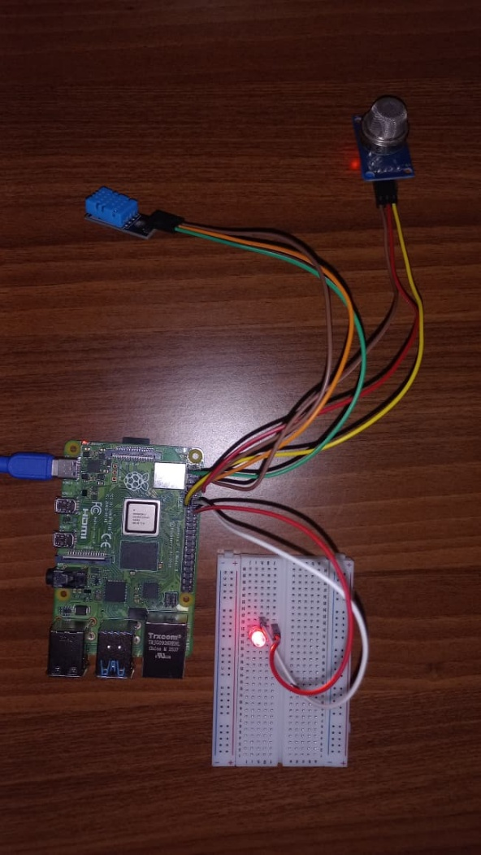

Implementation (Git)
The project implementation will involve:
• Programming the Raspberry Pi to collect sensor data.
• Sending sensor readings to the MQTT cloud broker.
• Logging washroom data into Google Sheets or a cloud database.
• Managing the project code, documentation, and updates using Git and GitHub.

Results / Output
The system continuously monitors washroom conditions and sends alerts when hygiene issues occur.
Examples:
• If ammonia levels exceed a threshold → alert is generated indicating bad odor.
• If the number of users increases significantly → monitoring system indicates peak usage times.
• If the floor becomes wet → alert is generated to ensure the washroom remains clean and safe.
• If soap levels drop below a threshold → alert is generated for soap refill.
Example alert message:
“Washroom 1 requires cleaning immediately.”
This allows sanitation staff and facility managers to respond quickly and maintain hygiene standards.

Challenges Faced
• Hardware Limitation: We did not have a micro-HDMI to HDMI converter for the Raspberry Pi, which prevented direct monitor access. To overcome this, we established an SSH connection from Windows Terminal to remotely access and configure the Raspberry Pi.
• Hardware Platform Shift Under Time Constraints: Our initial implementation was planned using an ESP32 microcontroller, but due to technical limitations we had to migrate the entire system to Raspberry Pi, requiring rapid reconfiguration and redevelopment within a limited time frame.
• Remote Access Configuration Issues: The VNC Server setup was not functioning as expected, preventing graphical remote access to the Raspberry Pi. As a workaround, we continued development primarily using terminal-based access through SSH.

Future Improvements
The system can be further enhanced with additional features, including:
• Mobile application dashboard for sanitation workers to receive alerts and monitor washroom conditions remotely.
• QR code-based user feedback system to combine sensor data with user satisfaction ratings.
• Advanced machine learning models for more accurate hygiene prediction.
• Integration with smart city infrastructure platforms for centralized facility management.
• AI integration to predict peak usage times and schedule cleaning proactively.

